Student Name:Saundarya Yadav

Student ID: 11704763

Email Address: saundarya19kashyap@gmail.com

Code:

#include<stdio.h>

int main()

{

int count, m ,i ,t ,r ,flag=0,time_quant;//t=time ,r=remaining time,

int wait_time=0,turnaround_time=0,arrival_time[10],burst_time[10],response_time[10];

printf("Enter Total Process:\t ");

scanf("%d",&i);

r=i;

for(count=0;count<i;count++)

{

printf("Enter Arrival Time and Burst Time for Process Process Number %d :",count+1);

scanf("%d",& arrival_time[count]);

scanf("%d",&burst_time[count]);

response_time[count]=burst_time[count];

}

printf("Enter Time Quantum:\t");

scanf("%d",&time_quant);

printf("\n\nProcess\t|Turnaround Time|Waiting Time\n\n");

for(t=0,count=0;r!=0;)

{

if(response_time[count]<=time_quant && response_time[count]>0)

{

t+=response_time[count];

response_time[count]=0;

flag=1;

}

else if(response_time[count]>0)

{

response_time[count]-=time_quant;

t+=time_quant;

}

if(response_time[count]==0 && flag==1)

{

r--;

printf("P[%d]\t|\t%d\t|\t%d\n",count+1,t-arrival_time[count],t-arrival_time[count]-burst_time[count]);

wait_time+=t-arrival_time[count]-burst_time[count];

turnaround_time+=time-arrival_time[count];

flag=0;

}

if(count==i-1)

count=0;

else if(arrival_time[count+1]<=t)

count++;

else

count=0;

}

printf("\nAverage Waiting Time= %f\n",wait_time*1.0/n);

printf("Avg Turnaround Time = %f",turnaround_time*1.0/n);

return 0;

}

}

Description:

Algorithm for development of scheduler which submits the process to the processor by interrupting the processor after every 6 units of time and it also check for the no. of process waiting for and allots the processor to the process after every iteration to manage the allocation of resources .Consider four process namely A, B, C and d to three processes P1, P2, P3 and P4

Suppose P1 has arrival time 0 and burst time 20.

P2 is having 5 and 36.

P3 having 13 and 19.

P4 is having 26 and 42.

And after every iteration scheduler checks for the process waiting in the queue for the processor and allot the more time to he process which need it.

Algortithm:

Given problem is solved using round robin in which time quantum is 6 unit and arrival time and burst time is given.

Steps:

1.Execution of process is done by making Gantt Chart .

2.Check the arrival time and then pick up the process allot 6 unit of time .

3.After the Gantt chart made calculate waiting time ,turnaround time and average time .

4.Calculated remaining time of the process.

Test case:

Case1:

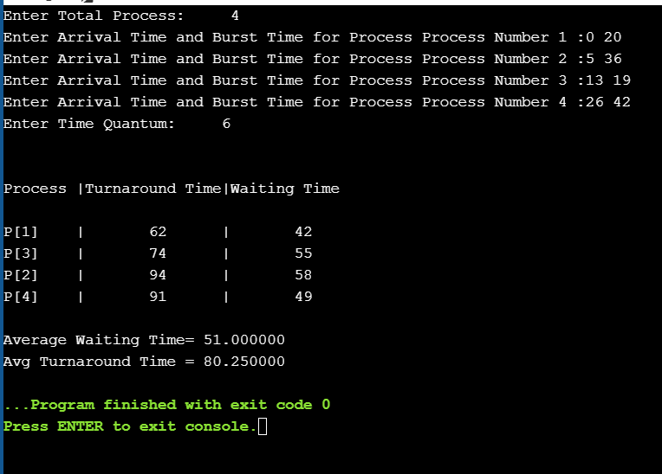

Case 2: 